**Azure Fundamentals (Az-900) Interview Questions and Answers**

1. **What is Cloud Computing ?**
2. **What is the Scalability of Cloud Computing ?**
3. **What is PasS, SaaS, IaaS ?**
4. **Explain different deployment models in loud ?**
5. **What are the main functions of Azure Cloud Services ?**

**Answer:** The main functions of the Azure Cloud Service are;

* It is designed to host the running application and at the same time manage the background running application.
* The application of web processing is termed as “web role” whereas the background processing is termed as the “worker role”.

1. **What is the Purpose of cloud Configuration file ?**

**Answer:**There is a primary .csfg file available with each and every cloud service. The main purpose of this file is

* They hold the main copy of certificates.
* They have the storage of user-defined settings.
* There are a number of instances in any service project.

1. **Which services are used to manage the resources in Azure ?**
2. **Explain different types of Roles ?**

**Answer:**There are basically three different types of roles;

* **Web Role** that is used to deploy website by making use of language which is supported by the IIS platform customized to run the web application.
* **VM Role** is used to schedule the window services and task. It is done by the user through customization of the machine on which the worker’s role is running.
* **Worker Role** is to execute the process that runs in the background by deploying the website.
* 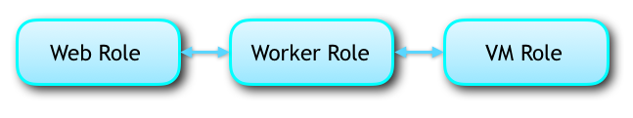

1. **What do you mean by Domain ?**
2. **Explain Fault Domain and Update Domain ?**
3. **Differentiate between Verbose and minimal monitoring ?**

|  |  |
| --- | --- |
| **Repetitive / Verbose Monitoring** | **Minimal Monitoring** |
| It collects metrics based on performance | It is a default configuration method |
| It allows a close analysis of data fed during the process of application | It allows a close analysis of data fed during the process of application |

1. **Explain BLOB and types ?**
2. **What is meant by DeadLetter Queue ?**

**Answer:** Messages are transferred to the DeadLetter queue in the following situation;

* When the delivery count has exceeded for a message that is on a queue.
* When the expiry date of the message has crossed and the entire expired message is held in a queue.
* When there is an evaluation exception set by default and the subscription is enabled with dead letter filter.

1. **How is the price of the Azure Subscription placed ?**

**Answer:**The prices vary in accordance with the product type. The various pricing models are;

* **The free model** where our customers can avail the system exempted from the market fee.
* **The BYOL scheme** where the Azure is fetched the Azure with a fee that is not encircled around the limits of market price.
* **The trial of the free software** where the client gets the full version with an advanced feature for a limited period of time. With the expiration of the introductory period, you will be charged standard rates.
* **Usage Based Fee** that is billed in accordance with the service that you have taken. Like if you are subscribed for the virtual image then hourly fees may be charged.
* **Monthly bills** are activated if you sign a particular plan. The fee is not allocated for cancellation or mid-month unused service.

1. **What is meant by Table Storage ?**
2. **Differentiate between Repository and Powerhouse Server ?**

**Answer:**Repository servers are those which are in lieu of the integrity, consistency, and uniformity whereas the powerhouse server governs the integration of different aspects of the database repository.

1. **What is Lookup transformation ?**

**Answer:** Lookup transformation aids to determine source qualifier. It can be active or passive lookup transformation. The process is yield to get the access the relevant information or the data.

1. **What is Connected and Unconnected Lookups ?**

**Answer:**

In the **unconnected** lookup, the input is directly taken from the transformation that takes part in the flow of data. The **connected** data lookup is built as both a static and dynamic cache. This can be oriented via multiple ports that can give the output. It is defined by user defined entity.

1. **What are the traffic Manager in Window Azure ?**

**Answer:** Traffic manager is allocated to control the distribution of the user to deploy the cloud service. The benefit of the traffic manager constitutes;

* It makes the application to be available worldwide through automated traffic control machinery.
* The traffic managing service contributes to high performance by loading the page faster and convenient usage.
* There is no lag of time to maintain or upgrade the existing system. The system keeps running in the back while the system takes time for up gradation.
* The configuration is made easy through the Azure portal.

1. **What is ARM and ARM Template ?**
2. **What you will do in case of a Drive Failure ?**

**Answer:**

* 1. The first is that the drive should be not mounted enabling the object storage to function without fail.
  2. The second scenario is replacing the drive in which the desired step will be remounting, formatting the drive.

1. **What is PROC SUMMARY and PROC MEANS ?**

**PROC MEANS** refers to the subgroup statist created in the persistence of the BY statement that will be involved. The data here is sorted beforehand with the assistance of BY variables.

**PROC SUMMARY**is the aid of statistics giving all varieties of information running simultaneously and is produced for every subgroup automatically. The information in the outlet is not created.

1. **If the Client gets disconnected from cache with the Services state the probable cause ?**

**Answer:** If the client gets disconnected the causal factor can be distributed into two categories;

The cause on the operator side;

* There might be a failure in the transfer of the standard cache from one node to the other.
* While the service was processing and dispatching the cache got deployed.
* There was a server update or an automated VM maintenance.

The fault on the client side;

* The application of the client accidentally got redeployed.
* The application on the client side got auto-scaling.
* The layer of the network on the client side altered.
* There was a transient error on the network node.
* The bound operation took more time.
* The upper limit of the bandwidth was reached.

1. **What are the instance Types Offered by Azure ?**

Azure offers a number of different instance types based on what needs they fulfill.

* **General Purpose -** CPU to memory ratio is balanced. Provides low to medium traffic web servers, small to medium databases and is ideal for testing and development

Largest instance size: Standard_D64_v3

256 GB Memory and 1600 GB SSD Temp Storage

* **Compute Optimized -** High CPU to memory ratio. Best suited for medium traffic web servers, application servers, batch processes, and network appliances

Largest instance size: Standard_F72s_V2

144 GB Memory and 576 GB SSD Temp Storage

* **Memory-Optimized -** High memory to CPU ratio. Best suited for relational database servers, in-memory analytics, and medium to large caches

Largest instance size: Standard_M128m

3892 GB Memory and 14,336 GB SSD Temp Storage

* **Storage Optimized -** Provides high disk IO and throughput. Best suited for Big Data, NoSQL and SQL Databases

Largest instance size: Standard_L32s

256 GB Memory and 5630 GB SSD Temp Storage

* GPU - Virtual Machines that specialize in heavy graphic rendering and video editing. It also helps with model training and inferencing with deep learning

Largest instance size: Standard_ND24rs

448 GB Memory and 2948 GB SSD Temp Storage  
4 GPUs and 96 GB Memory

* High-Performance Compute - Provides Azure’s fastest and powerful CPU virtual machines with optional high throughput interfaces

Largest instance size: Standard_L32s

224 GB Memory and 2000 GB SSD Temp Storage

1. **How is Windows Active Directory and Azure Active Directory different?**

|  |  |
| --- | --- |
| **Windows Active Directory** | **Azure Active Directory** |
| It is a directory service that facilitates working with interconnected, complex and different network resources in a unified manner | [Azure Active Directory](https://www.simplilearn.com/tutorials/azure-tutorial/azure-active-directory) (Azure AD) is Microsoft’s multi-tenant, cloud-based directory and identity management service |
| Uses 5 layers to store data, store user details, issue and manage certifications, etc. | Uses 5 layers to store data, store user details, issue and manage certifications, etc. |
| Works with an emphasis on on-premises units like applications, file services, printers, etc. | Emphasizes on web-based services that use RESTful interfaces |

1. **What are the Types of Queues offered by Azure ?**

Azure offers two types of queues:

**Storage Queues:**

* It is a part of Azure’s Storage infrastructure
* It provides messaging within and between services
* It is best suited when users need to store more than 80 GB of messages in queues
* It can provide side logs of all transactions executed against the user’s queues

**Service Bus Queues:**

* It is a part of Azure’s messaging infrastructure
* It integrates application or application components that span multiple communication protocols, network environments, etc.
* It provides a FIFO style of delivery
* The user’s queue size has to remain under 80 GB

1. **Advantage of ARM ?**

Azure Resource Manager enables users to manage their usage of application resources. Few of the advantages of Azure Resource Manager are:

* ARM helps deploy, manage and monitor all the resources for an application, a solution or a group
* Users can be granted access to resources they require
* It obtains comprehensive billing information for all the resources in the group
* Provisioning resources is made much easier with the help of templates

1. **How has integrating Hybrid Cloud been useful for Azure ?**

The Hybrid Cloud boosts productivity by using Azure and the Azure stack for building and deploying applications for the cloud and on-premises applications. Integrating hybrid cloud been useful for Azure in the following ways:

* It obtains greater efficiency with a combination of Azure services and DevOps processes and tools
* Users can take advantage of constantly updated Azure services and other Azure Marketplace applications
* It enables it to be deployed regardless of its location, the cloud, or on-premises.
* This enables applications to be created at a higher speed

1. **What is federation in Azure SQL ?**

**SQL Azure Federation** provides tools that can enable developers to access or share databases among themselves in SQL Azure.

* It enables users to take advantage of resources within the cloud
* It allows users to have their own database or share databases amongst each other
* It reduces the possibility of a single point of failure
* It provides cost-effectiveness, by using cloud resources only when needed

1. **Explain different types of storage Offered by Azure ?**

Azure has four different types of storage. They are:

**Azure Blob Storage**

Blob Storage enables users to store unstructured data that can include pictures, music, video files, etc. along with their metadata.

* When an object is changed, it is verified to ensure it is of the latest version.
* It provides maximum flexibility to optimize the user’s storage needs.
* Unstructured data is available to customers through REST-based object storage

**Azure Table Storage**

Table Storage enables users to perform deployment with semi-structured datasets and a NoSQL key-value store.

* It is used to create applications requiring flexible data schema
* It follows a strong consistency model, focusing on enterprises

**Azure File Storage**

File Storage provides file-sharing capabilities accessible by the SMB (Server Message Block) protocol

* The data is protected by SMB 3.0 and HTTPS
* Azure takes care of managing hardware and operating system deployments
* It improves on-premises performance and capabilities

**Azure Queue Storage**

Queue Storage provides message queueing for large workloads

* It enables users to build flexible applications and separate functions
* It ensures the application is scalable and less prone to individual components failing
* It enables queue monitoring which helps ensure customer demands are met

1. **How Can Azure handle below situation ?**

A client wants the front end of his/ her application to be hosted on Azure, but wants the database to be hosted on-premises.

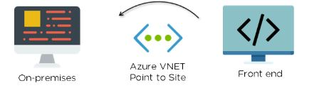

**Solution** –

The ideal solution in this scenario is to use **Azure VNET** based “**Point to Site**”. It’s best suited for scenarios where there are only a limited number of resources that need to be connected

1. **What is Azure Traffic Manager ?**

Azure Traffic Manager is a traffic load balancer that enables users to provide high availability and responsiveness by distributing traffic in an optimal manner across global Azure regions.

* It provides multiple automatic failover options
* It helps reduce application downtime
* It enables the distribution of user traffic across multiple locations
* It enables users to know where customers are connecting from

1. **How can Azure handle below Situation ?**

You need to isolate network traffic among VMs in a subnet, which is part of a [Virtual Network](https://www.simplilearn.com/tutorials/azure-tutorial/azure-virtual-network-vnet) with little downtime and impact on users?

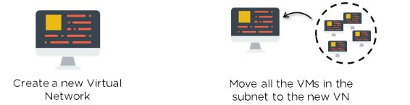

**Solution** –

This would ensure that the virtual machines are kept isolated without the need for additional security, like a Network Security Group.

1. **How you can handle below Scenario ?**

**Q : You need to make sure your Virtual Machines are able to communicate securely with each other to ensure security ?**

**Solution** -  Azure Virtual Network enables Azure resources to communicate with each other, the internet, or on-premises networks securely.

* Users can create their own private networks
* It provides users with an isolated and highly secure environment for applications
* All traffic stays within the Azure network
* It allows users to design their own networks

1. **How can you handle below Scenario ?**

**You need to ensure that every time a user logs in, they are not asked to re-enter their passwords as part of the authentication.**

a. To enable Microsoft Account authentication

b. Deploy ExpressRoute

c. Set up a VPN between premises and datacenter. Set up an AD domain controller in VM and implement integrated Windows Authentication

d. Configure Azure AD Sync to use single sign-on

**Solution - d) Configure Azure AD Sync to use single sign-on**

1. **You need to ensure that virtual machines remain available while migrating to Azure. What would be the appropriate service to use?**

**Ans : Express Route**

1. **Your standard tier application is used across the world and uses the Azure website standard tier. It uses a large number of image files. However, this causes the application to load slowly ?**

a. Configure Azure blob storage with a custom domain

b. Configure Azure website Autoscaling to increase instances at high loads

c. Configure Azure CDN to cache all responses from the application’s web endpoint

d. Configure Azure CDN to cache site images and content stored in Azure blob storage

**Ans :** Configure Azure CDN to cache site images and content stored in Azure blob storage.

1. **What is Azure VNet and Advantage ?**

* An [Azure](https://www.simplilearn.com/tutorials/azure-tutorial/what-is-azure) Virtual Network (VNet) is a network or environment that can be used to run VMs and applications in the cloud.
* When it is created, the services and Virtual Machines within the Azure network interact securely with each other.

## **Advantages of Using Azure Virtual Network**

Some of the major advantages of using Microsoft Azure VNet are as follows:

* It provides an isolated environment for your applications
* A subnet in a VNet can access the public internet by default
* We can easily direct traffic from resources
* It is a highly secure network
* It has high network connectivity
* It builds sophisticated network topologies in a simple manner

1. **What are the Components of Azure VNet ?**

Azure networking components provide a wide range of functionalities that can help companies build efficient cloud applications that meet their requirements.

The components of Azure Networking are listed below, and we have explained each of these components in a detailed manner:

1. Subnets
2. Routing
3. Network Security Groups

### **Subnets**

* Subnets let users segment the virtual network into one or more sub-networks.
* These sub-networks can be separated logically, and each subnet consists of a server.
* We can further divide a subnet into two types:

1. **Private**
2. **Public**

* **Private** - Instances can access the Internet with NAT (Network Address Translation) gateway that is present in the public subnet.
* **Public** - Instances can directly access the internet.

### **Routing**

* It delivers the data by choosing a suitable path from source to destination.
* For each subnet, the virtual network automatically routes traffic and creates a routing table.

### **Network Security Groups**

* It is a firewall that protects the virtual machine by limiting network traffic.
* It restricts inbound and outbound network traffic depending upon the destination [IP addresses](https://www.simplilearn.com/tutorials/cyber-security-tutorial/what-is-an-ip-address), port, and protocol.

1. **How to launch an Instance using Azure VNet ?**
2. 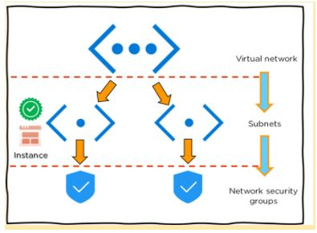

* First, create a virtual network in the [Azure cloud](https://www.simplilearn.com/azure-cloud-services-and-its-importance-article)
* Next, create subnets into each virtual network
* Now, assign each subnet with the respective instance or Virtual Machine
* After which you can connect the instance to a relevant Network Security Group
* Finally, configure the properties in the network security and set policies
* As a result, you will be able to launch your instance on Azure

Moving forward, we will see a demonstration on creating an Azure virtual machine and virtual network step-by-step.

## **Demo: Step-By-Step Demo of Creating Azure Virtual Machine and Virtual Network**

Step 1 − First, log into your Azure Management Portal, select 'New' at the bottom left corner.

Step 2 − Next,  on the Network Services go to Virtual Network -> Quick create.

Step 3 - Now, enter the name and leave all other fields empty and click 'next'.

Step 4 − Finally, click on 'Create a Virtual Network,' and it is done.

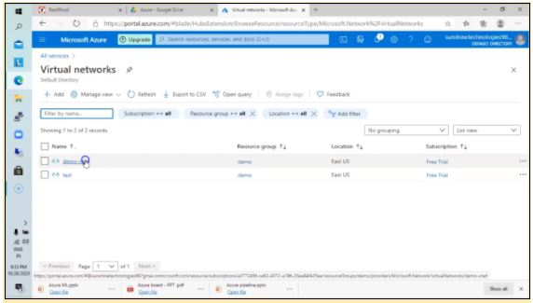

Note: Now, in the same VNet, create a Virtual machine

Step 5 - First, select ‘create’ to build a new Virtual Machine with Windows Server 2012 R2 Datacenter.

Step 6 - Once the fields are entered, select the existing resource group that you had created for the virtual network and select OK.

Step 7 - Now, choose a desired size and configuration by selecting DS1_V2 Standard type

Note: By default, we would choose a Virtual Network.

Step 8 - Now select the subnet as FrontEndSubnet and do not change the public IP address. Also, keep the Network Security Group as none.

Step 9 - Create a new availability set and set a new name to it.

Next, set the fault domains as 2 and then disable the Guest OS Diagnosis section.

Step 10 - Finally, click and select ‘create’.

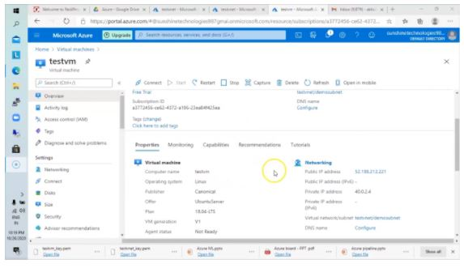

Congratulations, you have successfully created a VM.

This is all the basic information you need to know about Microsoft Azure Virtual Network.